**Setting Up Application Environment**

**Install IBM Cloud CLI**

|  |  |
| --- | --- |
| Date | 28 October 2022 |
| Team ID | PNT2022TMID17964 |
| Project Name | Skill and Job Recommender Application |
| Team Members: | Mridhul M, Pragadish SA, Megaloshini S, Priyadharshika R |

**Step 1:**

Follow and do the step given in this page one by one [***https://cloud.ibm.com/docs/cli/reference/ibmcloud_cli/get_started.html#getting-started***](https://cloud.ibm.com/docs/cli/reference/ibmcloud_cli/get_started.html#getting-started)

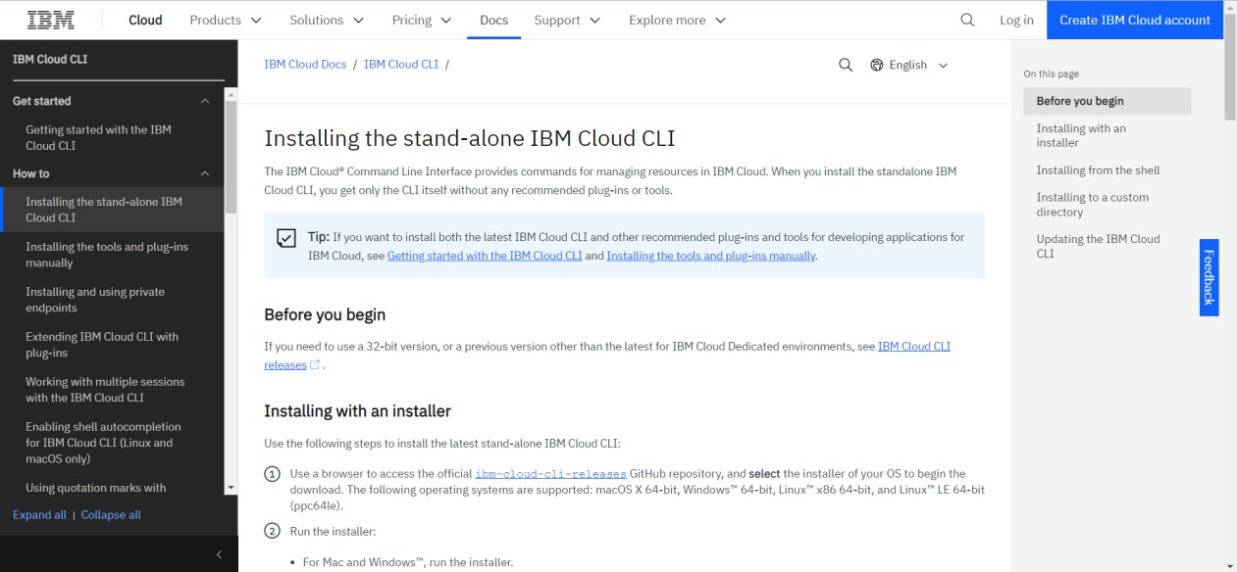

**Step 2:**

Download Setup file from the link [***https://github.com/IBM-Cloud/ibm-cloud-clirelease/releases/***](https://github.com/IBM-Cloud/ibm-cloud-cli-release/releases/)

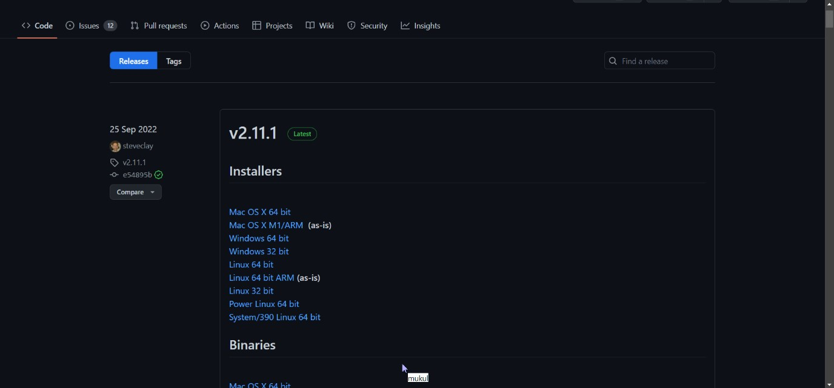

**Step 3:**

Run the setup file

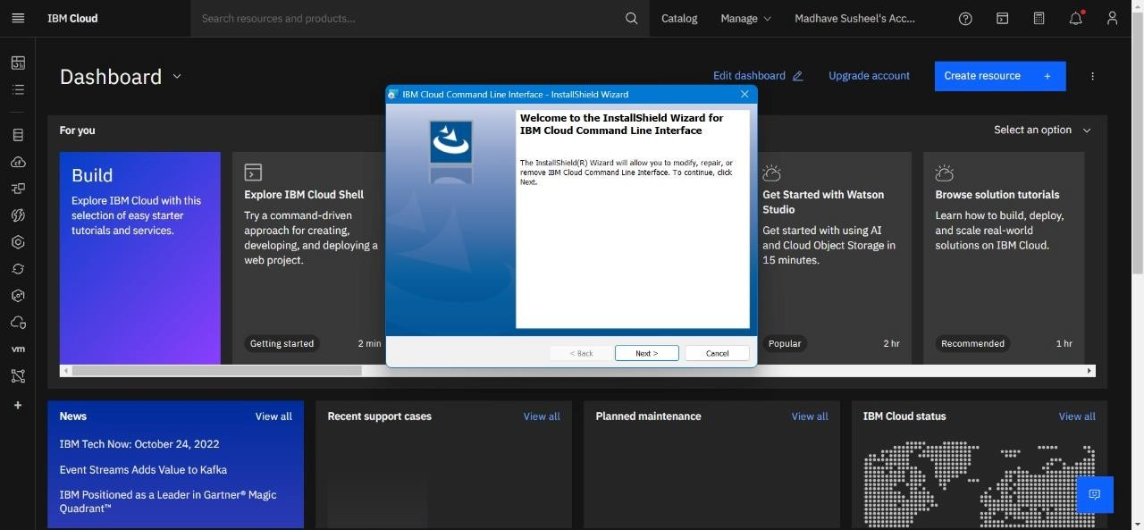

**Step 4:**

Check for updates and version in cmd

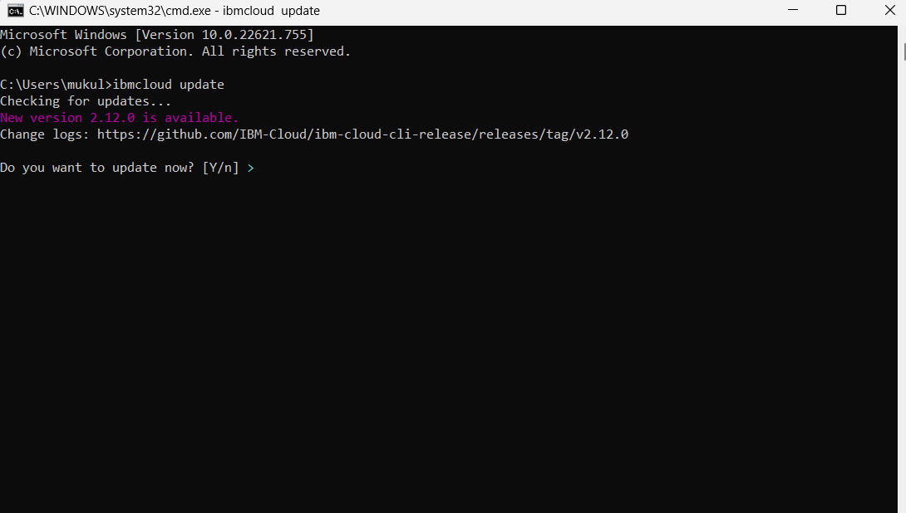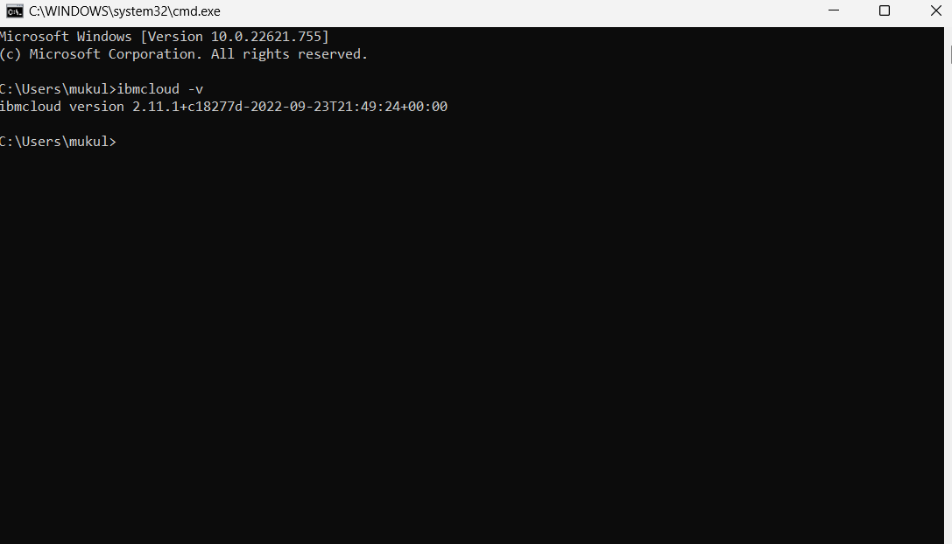

**Step 5:**

Run all the command one by one in cmd

[***https://cloud.ibm.com/docs/containers?topic=containers-cs_cli_install***](https://cloud.ibm.com/docs/containers?topic=containers-cs_cli_install)

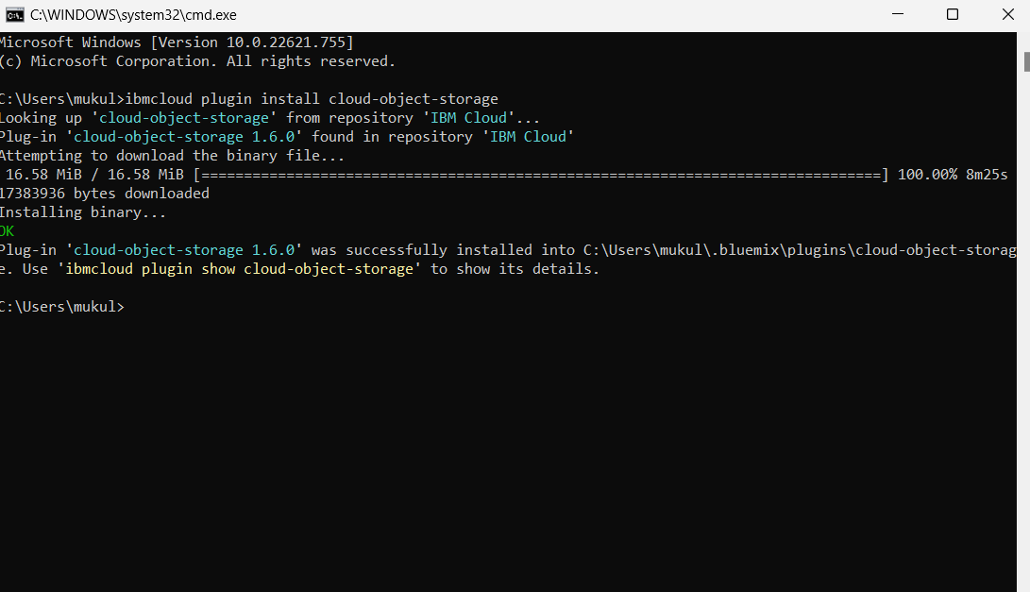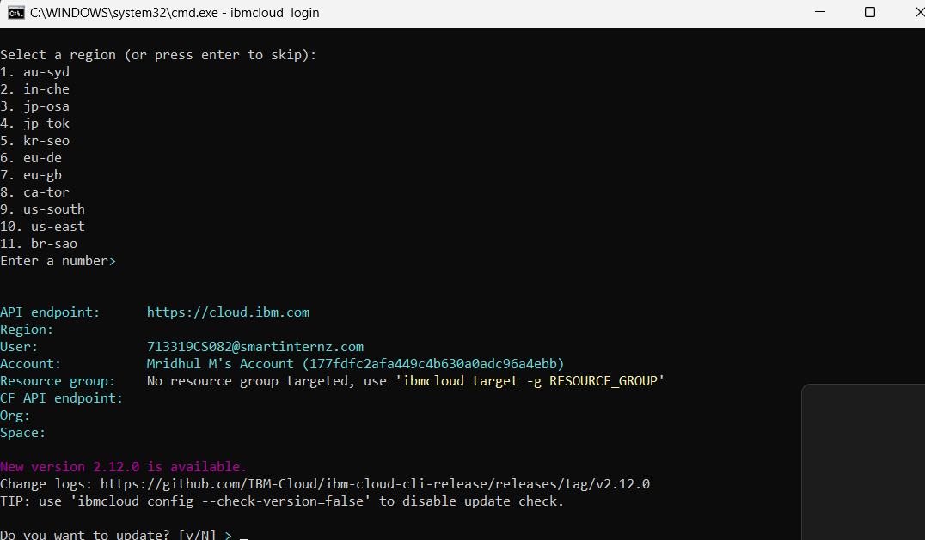

**Step 6:**

Finally, the process of installation of IBM Cloud CLI is Completed.